**DAILY ONLINE ACTIVITIES SUMMARY**

|  |  |  |  |  |  |  |  |  |
| --- | --- | --- | --- | --- | --- | --- | --- | --- |
| **Date:** | **18/05/2020** | | | | | **Name:** | **Netra suresh gudagamnala** | |
| **Sem & Sec** | **VI ‘A’** | | | | | **USN:** | **4al17cs055** | |
| **Online Test Summary** | | | | | | | | |
| **Subject** | | **CNSC** | | | | | | |
| **Max. Marks** | | **60** | | **Score** | | | **43** | |
| **Certification Course Summary** | | | | | | | | |
| **Course** | **Ethical hacking in python** | | | | | | | |
| **Certificate Provider** | | | **udemy** | | **Duration** | | | **1 month** |
| **Coding Challenges** | | | | | | | | |
| **Problem Statement:** Using methods charAt() & length() of String class, write a program to print the frequency of each character in a string. | | | | | | | | |
| **Status: done** | | | | | | | | |
| **Uploaded the report in Github** | | | | | **yes** | | | |
| **If yes Repository name** | | | | | <https://github.com/NETRASG/ALVAS_ONLINE_COADING> | | | |
| **Uploaded the report in slack** | | | | | **yes** | | | |

Online Test Details: (Attach the snapshot and briefly write the report for the same)

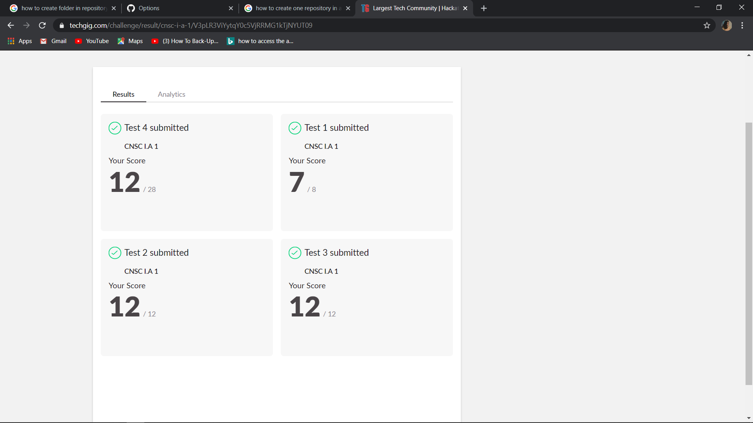

Certification Course Details: (Attach the snapshot and briefly write the report for the same)

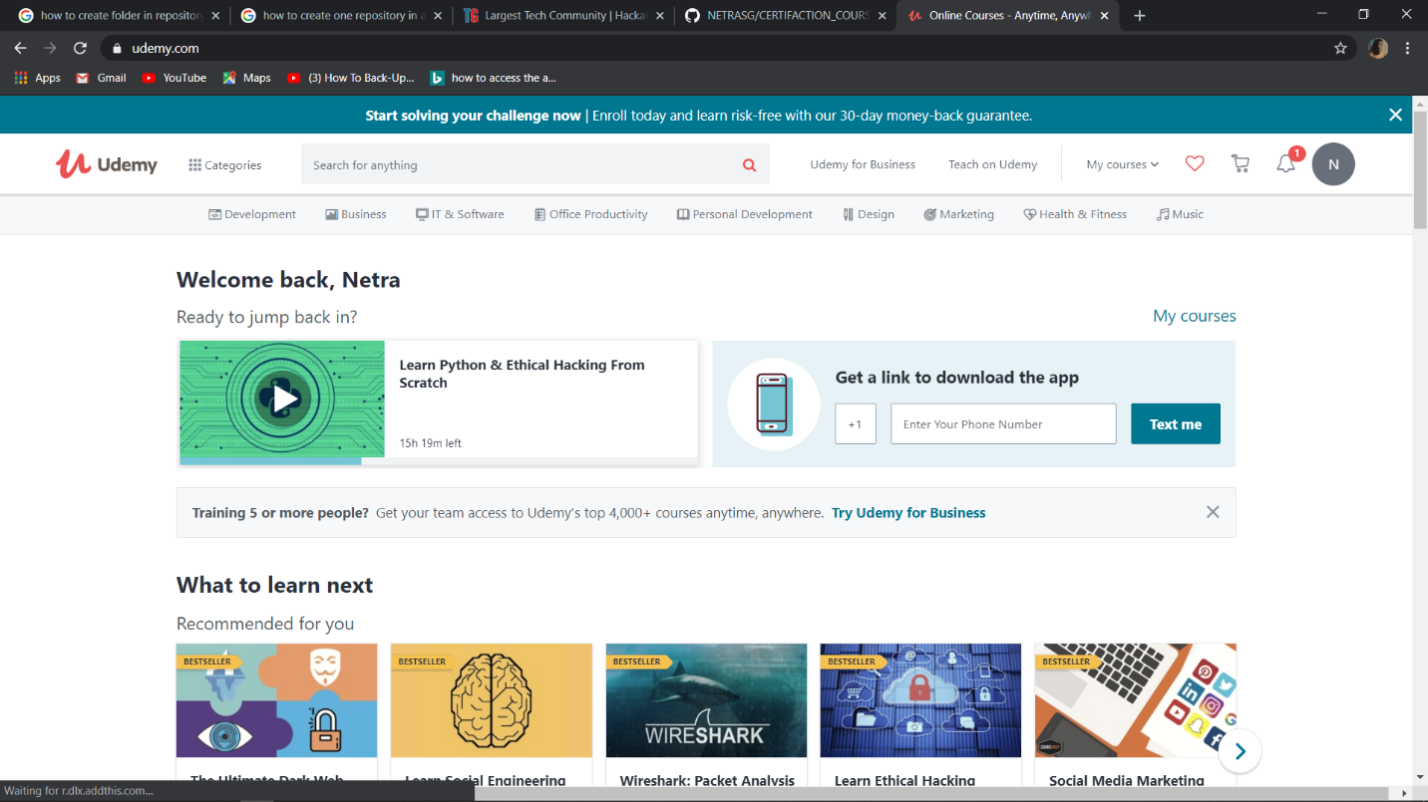

Introduction about the ethical hacking installation of virtual box and method of adding the virtual machine to tha virtual box